**Jenkins integration with Bitbucket**

**Jenkins Installation on windows server.**

**Prerequisite:**

Recommended hardware configuration for a small team:

* 1 GB+ of RAM
* 50 GB+ of drive space

Software requirements:

* Java 8 or ( higher version ) has to installed in windows server because Jenkins run on java.
* Install Apache2 to windows server

**Step1:** Go to IE/Chrome/Firefox and hit the Url [https://jenkins.io/download/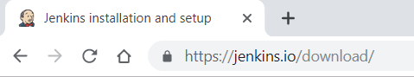](https://jenkins.io/download/)

**Step2:** Search for the latest LTS Generic java package (.war file) and download it.



**Step3:** Create the directory and copy the .war to that directory.

**Step4:** Go to Command Prompt and to created Jenkins directory Run **java –jar jenkins.war**

**Note:** Run the CMD as Administrator

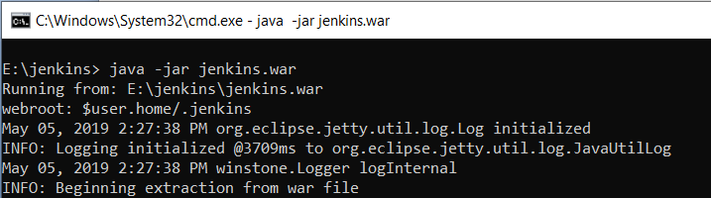

By Default Jenkins will take port 8080

By Default Jenkins will create the home directory in **C:\Users\91970\.jenkins\**

If you want to specify any other Port id run the .war with following **CMD: java -jar jenkins.war --httpPort=9090**

**Step5:** Go to browser and hit url http://localhost/:8080

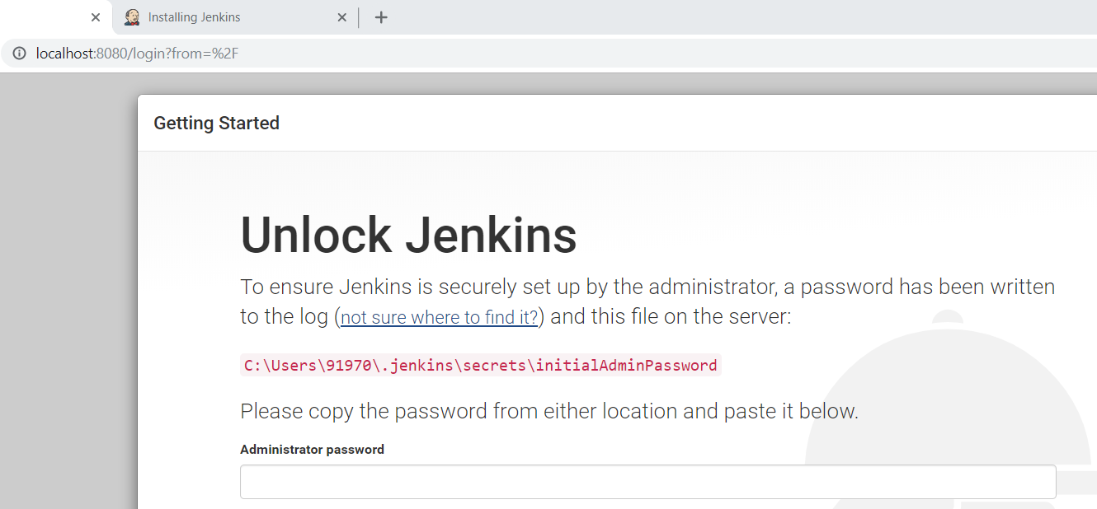

Look for the password in above mentioned Jenkins home directory

**Step6:** After [unlocking Jenkins](https://jenkins.io/doc/book/installing/#unlocking-jenkins), the **Customize Jenkins** page appears. Here you can install any number of useful plug-in as part of your initial setup.

Click one of the two options shown:

* **Install suggested plug-in** - to install the recommended set of plugins, which are based on most common use cases.
* **Select plug-in to install** - to choose which set of plug-in to initially install. When you first access the plug-in selection page, the suggested plug-in are selected by default.

|  |  |
| --- | --- |
| **Note:** | If you are not sure what plug-in you need, choose **Install suggested plug-in**. You can install (or remove) additional Jenkins plug-in at a later point in time via the [**Manage Jenkins**](https://jenkins.io/doc/book/managing) > **Manage plug-in>** page in Jenkins. |

The setup wizard shows the progression of Jenkins being configured and your chosen set of Jenkins plug-in being installed. This process may take a few minutes.

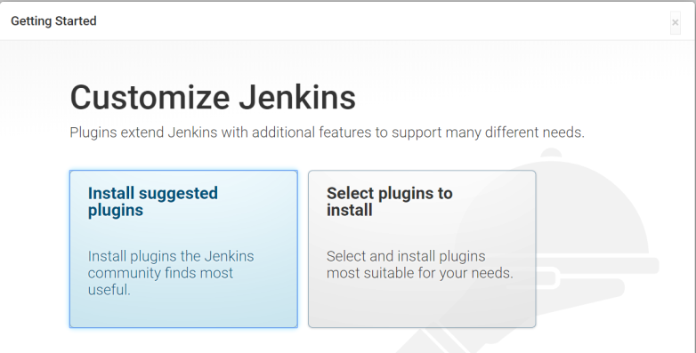

### Step7: Creating the first administrator user

Finally, after [customizing Jenkins with plug-in](https://jenkins.io/doc/book/installing/#customizing-jenkins-with-plugins), Jenkins asks you to create your first administrator user.

1. When the **Create First Admin User** page appears, specify the details for your administrator user in the respective fields and click **Save and Finish**.
2. When the **Jenkins is ready** page appears, click **Start using Jenkins**.  
   **Notes:**
   * This page may indicate **Jenkins is almost ready!** Instead and if so, click **Restart**.
   * If the page does not automatically refresh after a minute, use your web browser to refresh the page manually.
3. If required, log in to Jenkins with the credentials of the user you just created and you are ready to start using Jenkins!

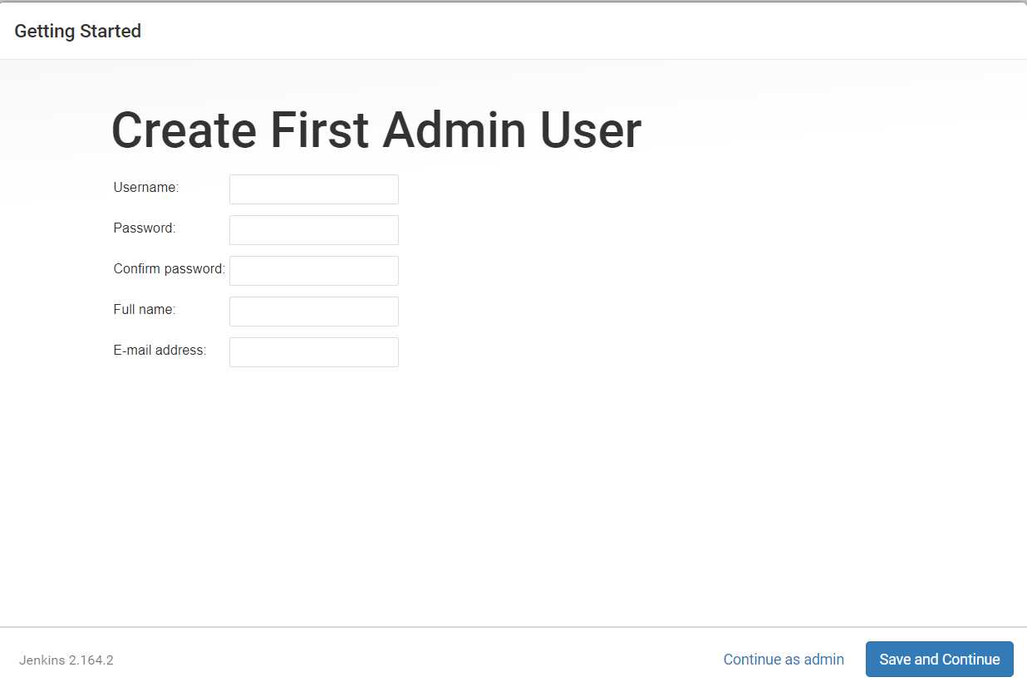

Enter above details and Jenkins is ready to Use by clicking start Jenkins

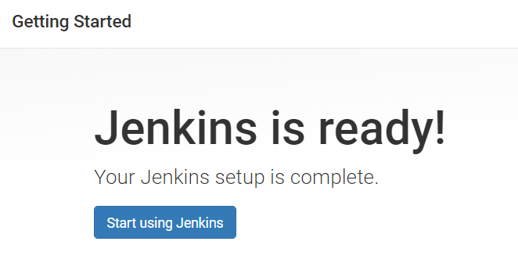

**Step8:** After Jenkins ready go to **Manage Jenkins > Global tool configuration** and define the java path which was install in your windows as a prerequisites and save.

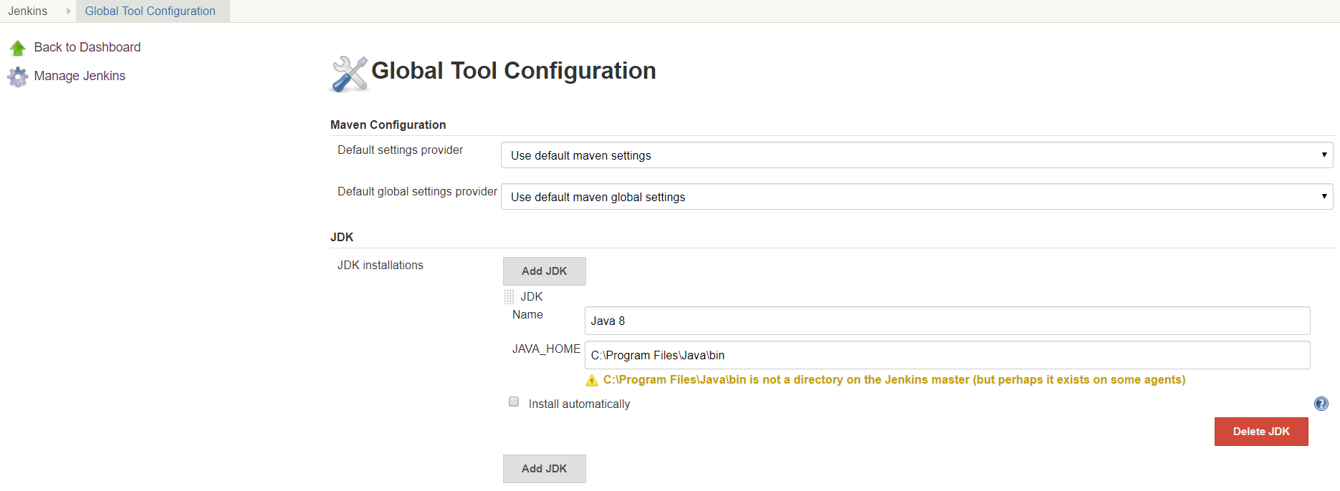

**Step9:** Install the Jenkins as service in windows So, every time you don’t need to Run the CMD to start Jenkins once you install windows service it will Run background.

Go to **Manage Jenkins > Install Jenkins as window Service.**

**Note:** CMD should run as Administrator otherwise you will get an Access denied to install the windows service.

Cross Check whether Jenkins is installing as Service or not.

By opening the task manager in windows and open onto service and search for Jenkins

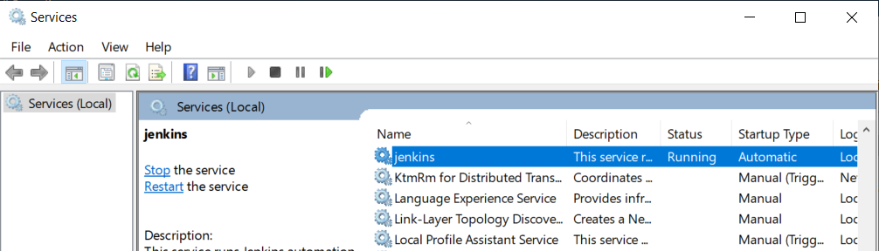

**Note:** Make sure that Local System Account is Checked and allow service to interact with Desktop is checked.

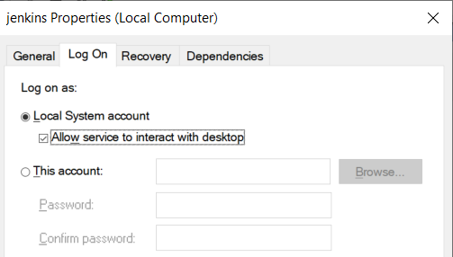

These has to be enable when you run the test cases Jenkins has to interact with Chrome driver and other services as well.

**Step10:** Installing the plug-ins that Required.

Go to Manage Jenkins > Manage plug-ins > Available Search for plug-ins and install.

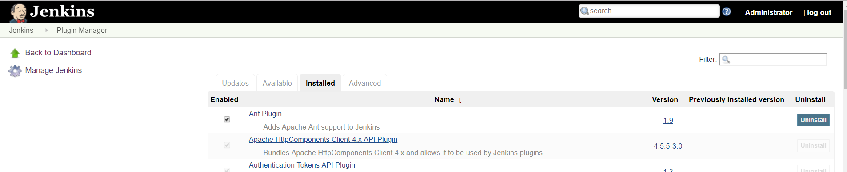

**Installing Bitbucket on windows Server.**